**Name: Shreyans Tatiya**

**Batch: C5_3 Roll No.: 16010123325**

**Experiment / assignment / tutorial No. 1**

**Grade: AA / AB / BB / BC / CC / CD /DD**

**Signature of the Staff In-charge with date**

|  |
| --- |
| **TITLE:** Write a program for:  a. Program to find area and circumference of various Geometric shapes.  b. Program to calculate EMI (Equated Monthly Instalment) of loan amount if principal, rate of  interest and time in years is given by the user.  (E = (P.r.(1+r)n) / ((1+r)n – 1) |

**AIM:** Write a program for:

a. Program to find area and circumference of various Geometric shapes.

b. Program to calculate EMI (Equated Monthly Instalment) of loan amount if principal, rate of

interest and time in years is given by the user.

E = (P.r.(1+r)n) / ((1+r)n – 1)

**____________________________________________________________**

**Expected OUTCOME of Experiment:**

1. Find area and circumference of various Geometric shapes
2. To calculate EMI

**_____________________________________________________________________**

**Books/ Journals/ Websites referred:**

1. Programming in ANSI C, E. Balagurusamy, 7 th Edition, 2016, McGraw-Hill

Education, India.

1. Structured Programming Approach, Pradeep Dey and Manas Ghosh, 1 st

Edition, 2016, Oxford University Press, India.

1. Let Us C, Yashwant Kanetkar, 15th Edition, 2016, BPB Publications, India.

**_____________________________________________________________________**

**Problem Definition:**

**Problem 1:** Area and Circumference of any shape(will be given by instructor) (example Circle)

Ask the user to enter the value of the radius of a circle. Put the values in the formula for finding area of a circle and circumference of a circle and print the outcome for area of a circle and circumference of a circle

**Problem 2:** Calculating EMI Ask the user to enter the value of principal amount, rate of interest and time (in years).Store the value in E and print the final monthly instalment E as an outcome.

Formula to be used: (E = (P.r.(1+r)n) / ((1+r)n – 1)

**Flowchart:**

**1)**

**a) Square**

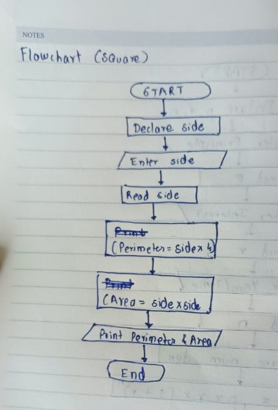

**b) circle**

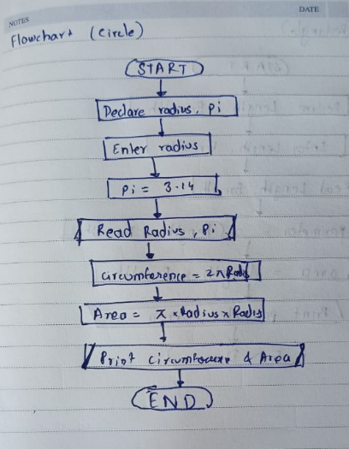

**c) rectangle**

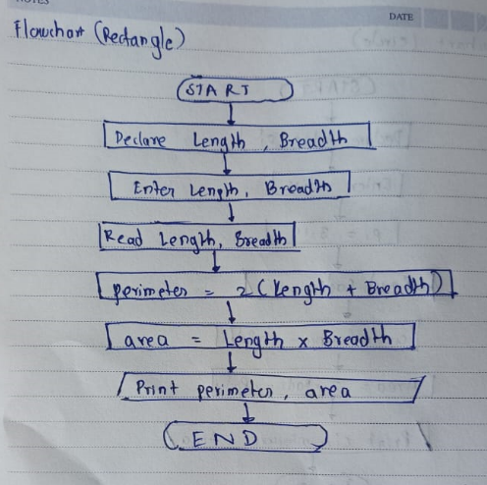

**d) triangle**

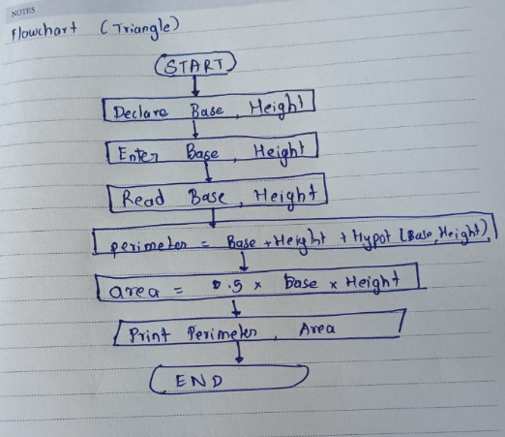

**2)**

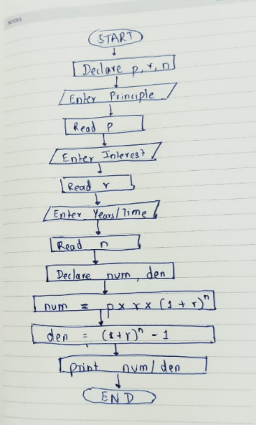

**Implementation details**

**1)**

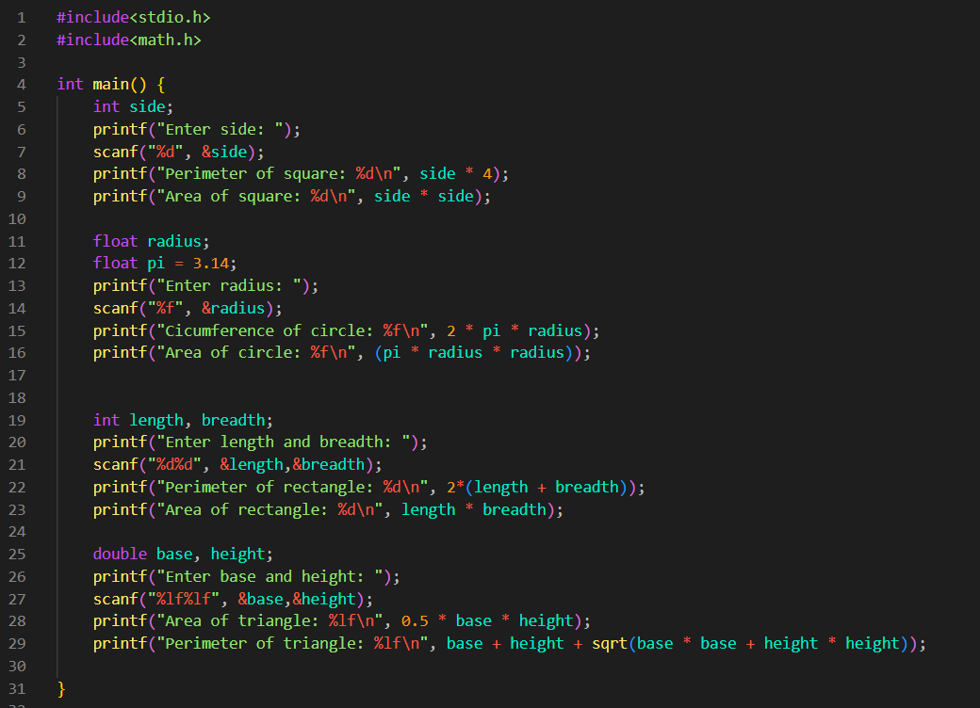

**2)**

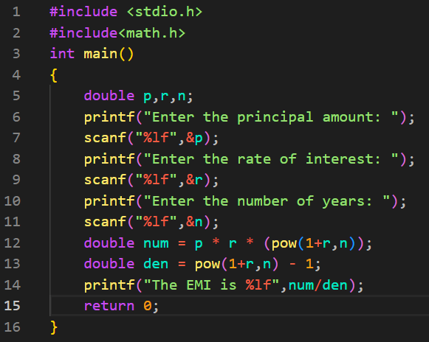

**Output(s):**

1)

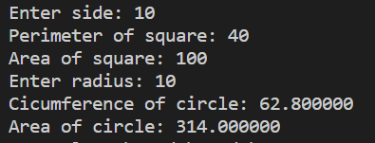

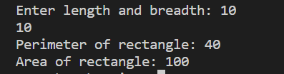

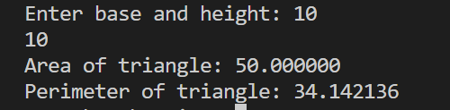

2)

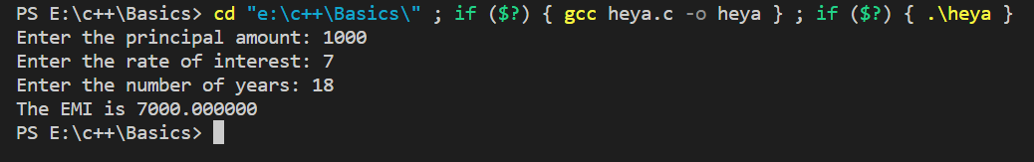

**Conclusion:**

Successfully executed out Experiment 1.

**Post Lab Descriptive Questions**

1. **What are the basic data types in C?**
2. **Write a table for Operator Precedence and Associativity.**

**Answers**:

1)

In C programming language, there are three categories of data types: primitive, user-defined, and derived data types.

Primitive data types are the most basic data types that are used for representing simple values such as integers, float, characters, etc

The following table lists the most commonly used primitive data types in C, along with their size, range, and format specifier:

**Table**

| **Data Type** | **Size (bytes)** | **Range** | | **Format Specifier** |
| --- | --- | --- | --- | --- |
| short int | 2 | -32,768 to 32,767 | | %hd |
| unsigned short int | 2 | 0 to 65,535 | | %hu |
| unsigned int | 4 | 0 to 4,294,967,295 | | %u |
| int | 4 | -2,147,483,648 to 2,147,483,647 | | %d |
| long int | 4 | -2,147,483,648 to 2,147,483,647 | | %ld |
| unsigned long int | 4 | 0 to 4,294,967,295 | | %lu |
| long long int | 8 | -(2^63) to (2^63)-1 | | %lld |
| unsigned long long int | 8 | 0 to 18,446,744,073,709,551,615 | | %llu |
| signed char | 1 | -128 to 127 | %c | |
| unsigned char | 1 | 0 to 255 | | %c |
| float | 4 | 1.2E-38 to 3.4E+38 | | %f |
| double | 8 | 1.7E-308 to 1.7E+308 | | %lf |
| long double | 16 | 3.4E-4932 to 1.1E+4932 | | %Lf |

User-defines data types are defined by the user and can be of any type, including primitive and derived data types.

Derived data types are data types that are derived from the primitive or built-in data types.

Examples of derived data types include arrays, pointers, structures and union

2)

Here, operators with the highest precedence appear at the top of the table, those with the lowest appear at the bottom. Within an expression, higher precedence operators will be evaluated first.

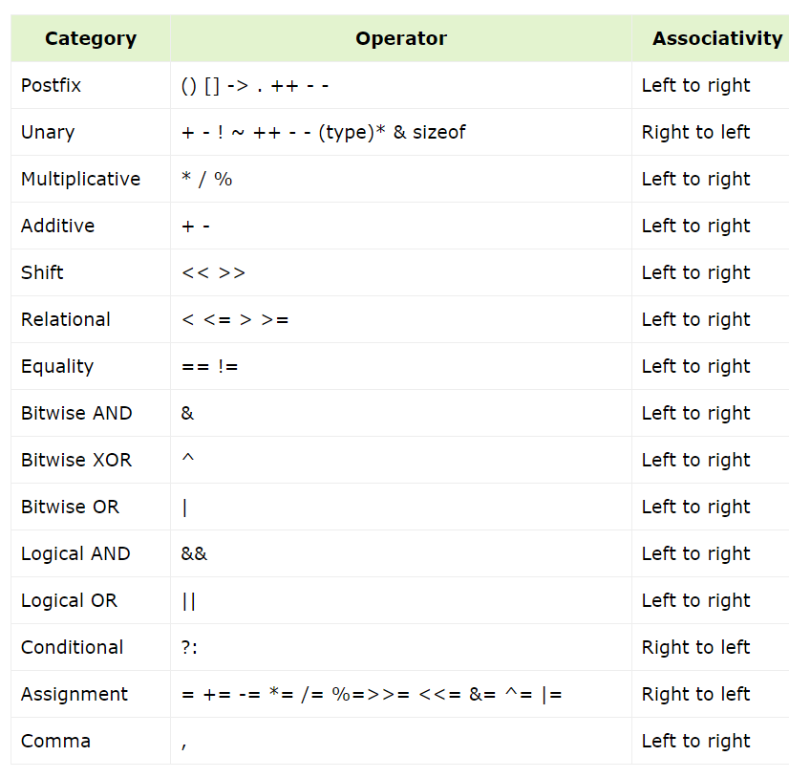

**Date: _____________ Signature of faculty in-charge**